***************** note : daily time price series alwyas gives the historical data even if you give the hist latest end date as todays 23 hrs it gives the till previous date data from hist oldest start date

** note get quote do not have dates to pass

Daily price series – always excludes

If daily price series take the where till date is passed as current date = take the top most row / record as prev date that is row[0]

If time price series passed with till date as current date , take row[-1] as previous date

Get quotes always gives the most recent data , and when queried pre market and post market it gives the the extended hrs ltp data

Case 1:

Input and execution Conditions:-

In below image asked to filter historical data “till” today’s 23 hrs ( todays date= 28-june-2024)

And “from” previous historical start date of 5 days back of till date which has till 23 hrs

Code ran time around 3.20 pm or 15.20 pm

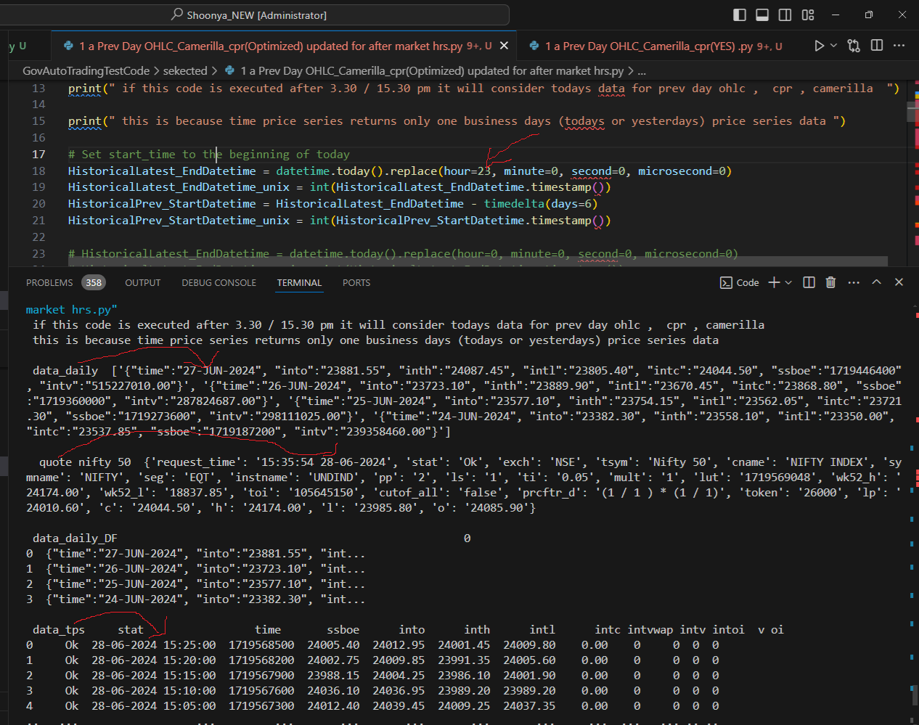

Results :

Look at above results daily price series most recent data ends with previous date data which is 27 june -24 , even if asked end date was till 28 – june -24

While time price series considers the most recent data end date if you give 28-june-24 if hrs is 23 hrs

And get quotes as ususual give current dates last and latest updated ltp details

Case 2:

Input and execution Conditions:-

As always the daily price series excludes current / latest end date even in case if you give 28 –june -24 00 hrs and returns data till 27

Get quote : gives latest

How ever time price series this time did not return the current / latest end dates data ( which is 28 june -24) when the end date is given as 28-june-2024 00 hrs , but returns data for 28 when hrs is given as 23 hrs for same 28-june-24

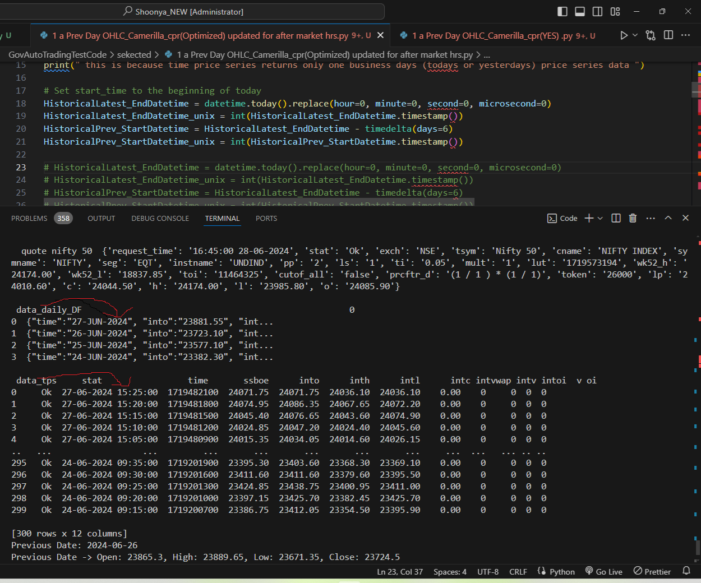

# Always make two time price series calls

1. One : for the prev days ohlc in else condition in case daily price series do not respond . where the end date is the previous date and pick data from row[0]
2. Second: for current days candle and trend calculation for indicators “plus ” combindely call and use the get quote for the first time of the day especially before the market open to include the post market and pre market trading ohlc
   1. But once the market commences make sure the live data get appended while caliculating the indicators